River Cutters: A Stream Table Activity
Vocabulary: stream channel, delta, erosion, deposition, alluvial fan, meander, watershed
Assign your Group Members to Duties:

- Recorder
- Cup monitor
- Timer/bailer
- Fetcher
- Observer (ALL!)
- Clean-up (ALL!)
Materials you will need:
- Plastic trays (around 22”x11”x2.5”) with a small (1/2”) hole in one end; you’ll want one per 2-4 students if possible
- For each sand table tray you need
- Sand mixture (make one bag for each stream table tray):
in a plastic bag mix together 4 or 5 cups fine grain sand + 1 cup clay
then add ~1 cup water and mix again
- Wooden ruler or wooden slat - 12“
- Wooden blocks for elevating end of stream table.
- Wooden block for smoothing sand
- Catch basin or bucket (plastic dish tubs work well)
- Drip cup slow: ~1 pint plastic container w/small hole (~1/8” diameter) in center of bottom
- Drip cup fast: ~1 pint plastic container w/ larger hole (~5/16” diameter) in center of bottom
- Pitcher or bottle of water - ~ 1L
- Timer
- Ruler
Set up your stream table:
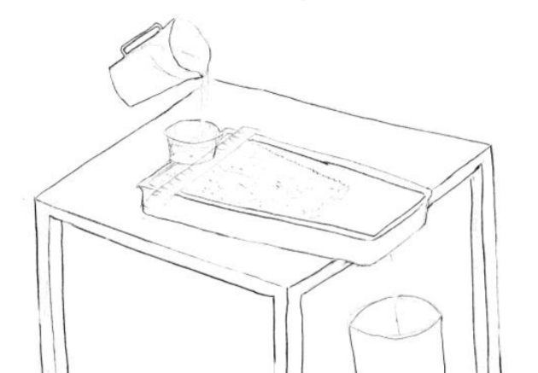
- Place the stream table tray on the edge of the table with the drain-hole a couple of inches over the edge of the table
- Add sand mixture to the stream table tray. Push the sand up so that it covers about 1/2 to 2/3 of the bottom of the tray. Smooth the sand with the smoother block – the smoother and flatter the better.

- Place a bucket under the edge of the table below the tray.
- Push the tray slightly over the edge of the table so that the drain-hole is directly over the bucket and will drain water into the bucket. (If it is too close to the table edge, water will flow onto and under the table)
- Raise the top end of the tray using the wooden block or smoother.
- Place a ruler or wooden slat across the top of the tray.
- Set the drip cup (small hole) on the ruler at the center of the back end of the tray (see diagram)
Run your first trial:
- Describe your set up in your notebook – What does the surface look like? How steep is the slope? What do you think will happen when water flows over the surface?
- Fill the drip cup with water, let run for 5 minutes (refilling the drip cup as needed).
- Describe and/or draw what you see happening – things to include are:
- What does the surface look like now?
- Where is the head of your river? Describe what is happening by the head of the river.
- Where is the mouth of your river? Describe what is happening at your river mouth?
- What are some ways you could describe what happened quantitatively?
- Discuss as a class what was observed – vocabulary to include is stream channel, delta, erosion, deposition, alluvial fan, meander
Variations:
Now try a run with either a steeper or flatter slope, or using a faster drip rate.
Make predictions about what might change – and then compare the results to the original results. Or open it up and jump right to the further investigations.
Further Investigation:
Once your students understand the basics of the stream table, let them do an investigation of their own question and design.
Investigations should include:
- A question
- Thinking about how the results will/might be different and why
- What kind of data to record
- Making and labeling of drawings
See additional challenges below for some ideas

If you prefer more structure, you can challenge students to investigate a variety of specific phenomena using the stream table and compare what they see to their original trial or to a standard of their own design. Again, be sure to
- Ask a clear question
- Think about how the results will be different and why – make a prediction with reasoning
- Figure out what kind of data to record; try to identify the independent variable (what you change or vary) and dependent variable (what you measure in response to the change)
- Make and label drawings
Some ideas for additional challenges
- Meandering stream -
See if you can make a meandering stream -- lower the gradient (slope) of your tray (make the tray angle a little flatter by changing the orientation of your wooden block, or put a smaller block under the end of the tray). Wait a few minutes and see if you get a meander.
Sketch the meandering stream. On your sketch indicate where erosion is taking place and where deposition is taking place in your meanders. Did an oxbow form? If not, where might one form?
- Create a dam -
Make a strip of overhead transparency with a v-notch in it. Make a U-shape with the strip and bury it partway in the sand with the “U” opening upstream. You have just created a dam. Start the water and observe what happens at the dam and below the dam. Where is there erosion? Where is the water moving? Where is there deposition? What happens to the channel? What happens to the delta?
- Create a waterfall -
Get a brick or large rock and place it directly under your dripper allowing the water to drip directly onto the brick or rock. As you wait a few minutes observe the river system, then describe what happens. Where do you have erosion? Where do you have deposition?
- Raise sea level -
Plug the drain hole with some tape or clay. Gently add some water to the end of the tray where the mouth of your river is. As you wait a few minutes observe what happens to your river system. Describe what happens.
- Lower sea level -
Increase the gradient of your tray (make it steeper). Gently scoop some water out of the end of the tray where the mouth of your river is. You have just lowered sea level. Start the water and observe what happens to your river system. Describe what happens.
- Create rapids -
Increase the gradient of your tray (make it steeper). Fetch some small rocks and stick them down in and around your channel using the rocks to narrow your river channel. Start the water and observe what happens to your river system.
- Explore the effect of sand grain size variation -
Increase the grain size of your sand mixture by adding pea gravel or pebbles, or decrease the grain size by adding more clay. Start the water and observe what happens to your river system. Describe what happens.
- Effect of plants or bank stabilization strategies-
Add trees or roots, or something else to give some structure to the substrate
- Pollute the river -
Increase the gradient of your tray (make it steeper). Get two or three q-tips or sponge pieces and apply some drops of food coloring. Poke or bury these “pollution sources” into the sand – you can try different distances from the channel and different depths. Observe what happens for a couple of minutes without water flowing and then start the water and observe what happens to your river system. Describe what happens. (Note - this may work better with a steeper gradient.) Think about what real life situations this models (e.g. underground and surface pollution sources, movement of water underground, movement of pollution in a watershed).
- Build some buildings or bridges to see how distance from the river, flow rate, etc. affects how well they survive, or how they affect erosion and deposition patterns and/or movement of water.
- Other ideas…..

Some videos of fluvial processes
Evidence of water on mars looks like a stream table experiment
https://www.youtube.com/watch?v=Jr1Xu2i-Uc0
Dam removal video and erosion
https://www.youtube.com/watch?v=4LxMHmw3Z-U
formation of the San Francisco Bay
http://education.savingthebay.org/wp-content/guides/The-Formation-of-San-Francisco-Bay.pdf
http://education.savingthebay.org/the-formation-of-san-francisco-bay
Grand Canyon erosion – start at 2:30 (shows model of river cutting into earth’s crust)
https://www.youtube.com/watch?v=A6JcJqRPD_8

