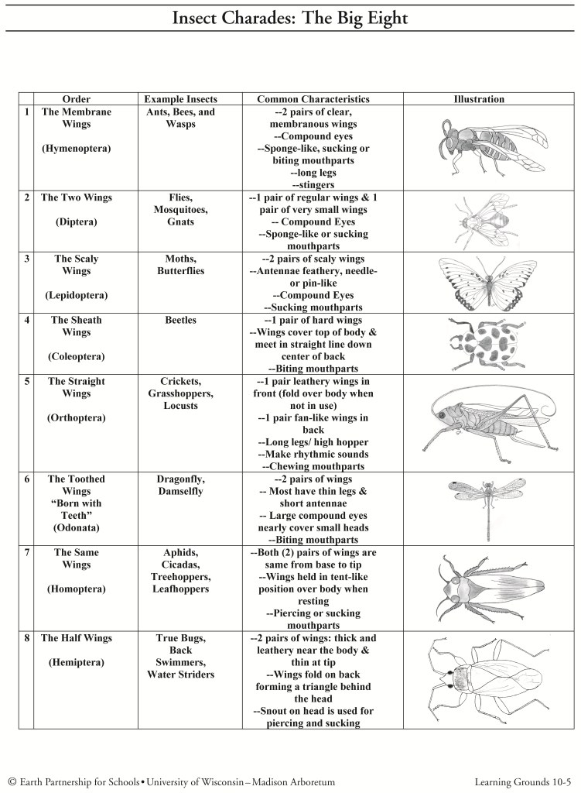
INSECT ORDERS – THE BIG EIGHT

