HOW DOES A WATERSHED WORK? A simple watershed model – with paper!
Overview: Students use crumpled paper to create a model demonstrating the basic features of a watershed and to explore the impacts of human activities on watersheds. They may also create the San Francisco Bay’s Watershed using their hands to represent major geographical features.

Estimated Time: 30 minutes

Objectives:
Students will be able to:
- Describe the major geographical features of San Francisco Bay’s Watershed.
- Define the term “watershed.”
- Use a model to understand how a watershed works.
Focus Question: How does a watershed work? (see
Learning concepts:
- A watershed is the area of land in which rain or snowmelt flows across or through on its way to a creek, river, lake, or ocean.
- A watershed extends from a high point, such as a ridgeline, down to a lower point where the water flows into a creek, river, bay, ocean, or other waterbody.
- Water flows downhill due to gravity
- Everyone lives in a watershed
- Everyone living in a Bay Area watershed can affect the health of the Bay
Materials:
- One sheet of 8 ½” X 11” paper for each student or pair of students (you can reuse one-sided paper for this activity)
- Water soluble markers in at least 3 colors
- Paper plates, trays or plastic tubs
- Spray bottles of water
- A pair of hands!

Vocabulary: watershed, ridge, slope, valley, drainage area, runoff,
(pollution, non-point source pollution)
Procedure
- Conduct this activity outside or in an area that can get slightly wet (lab area, tables with paper towels nearby, etc.) or do on plastic trays or inside of plastic tubs to contain the water.
- Introduce the model
- Pass out a piece of paper and water-soluble markers to each student or pair of students.
- Instruct the students to crumple their piece of paper into a ball and to gently open up the paper without flattening it out completely. It should look like a landscape with mountains and valleys.
- Have students color the ridgelines/high points that separate one valley from another with one color. Use a second color to represent where you think bodies of water such rivers or lakes will form on your landscape.
- In their notebooks, have students predict: when water flows on this landscape, where will it run the fastest? Where will streams and lakes form?
- Make it rain: place the paper model onto a paper plate or into a plastic tub. You may want to raise one end of the paper to give more directional slope. Use a spray bottle to lightly spray water onto the landscape (give students a spray bottle or walk around and spray for them). Observe where the water flows and pools
- Write observations in your notebook:
What happened?
Did you draw water in the correct places?
Where did the rain move quickly and slowly in the watershed?
Did the water pool up anywhere?
- Lead a discussion using some of the following questions:
- What path does the rain take on your landscape?
- How does this landscape represent the idea of a watershed?
- Evaluate the model
- In what ways does this model represent the real world, what processes are represented well?
- What is missing in the model?
- What else could you do with this model -- how might it help you visualize or predict things that might happen in the real world?
- Have students answer the focus question in their notebooks: how does a watershed work. You can also ask them to draw a model of a watershed using all of the vocabulary.
- Expand the model
Explore how pollution is transported into watersheds with rainstorms by adding housing developments and/or non-point source pollution (e.g. litter, factories, gardens using pesticides, roads with oil residues on them) to the landscape in another color.
When it rains, does the water flow across the housing development? How might the model help decide a good place for a housing development?
How does the water change color with human development in the watershed?
Where would you put human activities and structures to reduce pollution in the stream?
What can we do to reduce non-point source pollution?

Hand model of SF Bay watershed (see https://www.savesfbay.org/sites/default/files/WatershedCurriculum.pdf ):
You can use this either at the end to tie watersheds to the Bay Area, or as an introduction
•Put your hands together, palms upward, and curve them to make a bowl.
• Imagine that the tips of your fingers are the peaks of the Sierra Nevada Mountain Range. Your left thumb is Mount Shasta, your right thumb is the Tehachapi Mountain Range, and the fleshy parts at the bases of your thumbs are the Coastal Range.
• The cracks between your fingers are all the small creeks and rivers trickling down from the Sierras, such as the American, Kern, and Mokelumne.
• The large crease in your left palm (sometimes called your “lifeline”) represents the Sacramento River, and the crease in your right palm represents the San Joaquin River.
• The crack between your two hands represents the Delta, the opening between your arms is the Bay.
• Notice how the small creeks flow into the large rivers, which then flow into the Delta and out
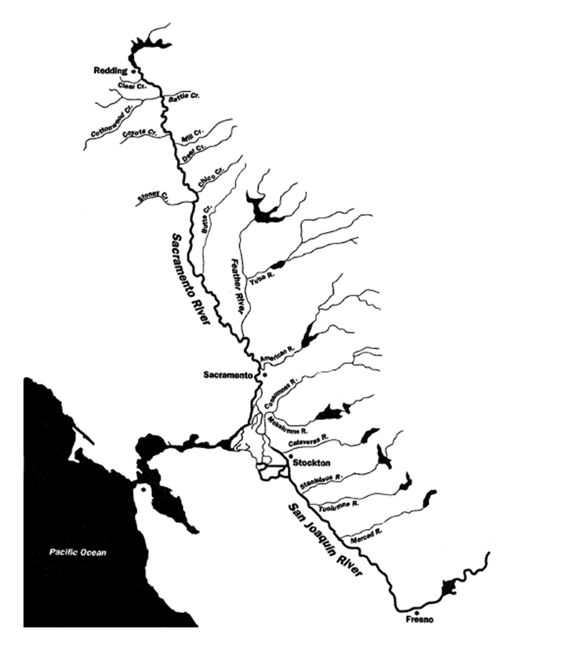
into the Bay!

Some sources for background info on watersheds NOAA: https://oceanservice.noaa.gov/facts/watershed.html
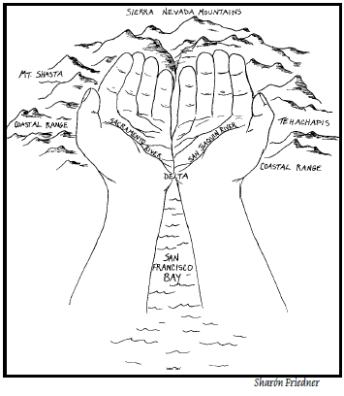
EPA: https://www.epa.gov/sfbay-delta/about-watershed)

BACKGROUND INFO on Nonpoint Source pollution (https://www.epa.gov/nps/what-nonpoint-source)
Nonpoint source pollution generally results from land runoff, precipitation, atmospheric deposition, drainage, seepage or hydrologic modification. Nonpoint source (NPS) pollution, unlike pollution from industrial and sewage treatment plants, comes from many diffuse sources. NPS pollution is caused by rainfall or snowmelt moving over and through the ground. As this runoff moves, it can pick up debris, chemicals, dirt, and other pollutants and flow into a storm sewer system or directly to a lake, stream, river, wetland, or coastal water. Anything that enters a storm sewer system is discharged untreated into the waterbodies we use for swimming, fishing, and providing drinking water. In urban areas precipitation from rain or snowmelt flows over more impervious surfaces like driveways, sidewalks, and streets which prevent storm water from naturally soaking into the ground and increases the flow of pollutants into streams and other bodies of water.
Nonpoint source pollution can include:
- Excess fertilizers, herbicides and insecticides from agricultural lands and residential areas
- Oil, grease and toxic chemicals from urban runoff and energy production
- Sediment from improperly managed construction sites, crop & forest lands, eroding streambanks
- Salt from irrigation practices and acid drainage from abandoned mines
- Bacteria and nutrients from livestock, pet wastes and faulty septic systems
- Atmospheric deposition and hydromodification
Effects
Polluted runoff can have many adverse effects on plants, fish, animals, and people.
Sediment can cloud the water and make it difficult or impossible for aquatic plants to grow. Sediment also can destroy aquatic habitats.
Excess nutrients (from fertilizers) can cause algae blooms. When algae die, they sink to the bottom and decompose in a process that removes oxygen from the water. Fish and other aquatic organisms can’t exist in water with low dissolved oxygen levels.
Bacteria and other pathogens can wash into swimming areas and create health hazards, often making beach closures necessary.
Debris—plastic bags, six-pack rings, bottles, and cigarette butts—washed into waterbodies can choke, suffocate, or disable aquatic life like ducks, fish, turtles, and birds.
Household hazardous wastes like insecticides, pesticides, paint, solvents, used motor oil, and other auto fluids can poison aquatic life. Land animals and people can become sick or die from eating diseased fish and shellfish or ingesting polluted water.
Polluted storm water often affects drinking water sources. This, in turn, can affect human health and increase drinking water treatment costs.
Non-point vs point source: The term "point source" means any discernible, confined and discrete conveyance, including but not limited to any pipe, ditch, channel, tunnel, conduit, well, discrete fissure, container, rolling stock, concentrated animal feeding operation, or vessel or other floating craft, from which pollutants are or may be discharged. This term does not include agricultural storm water discharges and return flows from irrigated agriculture.
Two big sources of NPS pollution are urban runoff and agriculture
Urbanization increases the variety and amount of pollutants carried into our nation's waters. In urban and suburban areas, much of the land surface is covered by buildings, pavement and compacted landscapes. These surfaces do not allow rain and snow melt to soak into the ground which greatly increases the volume and velocity of storm water runoff. In addition to these habitat-destroying impacts, pollutants from urban runoff include:
- Sediment
- Oil, grease and toxic chemicals from motor vehicles
- Pesticides and nutrients from lawns and gardens
- Viruses, bacteria and nutrients from pet waste and failing septic systems
- Road salts
- Heavy metals from roof shingles, motor vehicles and other sources
- Thermal pollution from impervious surfaces such as streets and rooftops
These pollutants can harm fish and wildlife populations, kill native vegetation, foul drinking water, and make recreational areas unsafe and unpleasant.

The National Water Quality Assessment shows that agricultural nonpoint source (NPS) pollution is the leading source of water quality impacts on surveyed rivers and streams, the third largest source for lakes, the second largest source of impairments to wetlands, and a major contributor to contamination of surveyed estuaries and ground water.

Agricultural activities that cause NPS pollution most generally occur in the absence of a conservation plan. Impacts can be generated from activities such as poorly located or managed animal feeding operations and manure, overgrazing, plowing too often or at the wrong time and improper application fertilizer.

What You Can Do to Prevent Nonpoint Source Pollution?

from Urban Stormwater Runoff
- Use fertilizers sparingly
- Avoid pesticides; learn about Integrated Pest Management (IPM)
- Keep litter, pet wastes, leaves and debris out of street gutters and storm drains (-these outlets drain directly to lake, streams, rivers and wetlands).
  - Sweep up driveways, sidewalks, and roads
  - Compost your yard waste
  - Pick up after your pet
- Never dump anything, especially chemicals, down storm drains
  - Dispose of used oil, antifreeze, paints and other household chemicals properly (-if your community does not already have a program for collecting household hazardous wastes, ask your local government to establish one).
  - Clean up spilled brake fluid, oil, grease and antifreeze. Do not hose them into the street where they can eventually reach local streams and lakes.
- Direct downspouts away from paved surfaces
- Take your car to the car wash instead of washing it in the driveway
- Check car for leaks, and recycle motor oil
- Inspect and pump your septic tank regularly
- Control soil erosion on your property - plant ground cover in bare spots in your yard.
- Encourage local government officials to develop construction erosion and sediment control ordinances in your community.
- Buy household detergents and cleaners that are low in phosphorous.

From Agriculture
Manage animal manures to minimize losses to surface water and ground water.
Reduce soil erosion and nutrient loss by using appropriate conservation practice systems and other applicable best management practices.
Use planned grazing systems on pasture and rangeland.
Dispose of pesticides, containers, and tank rinsate in an approved manner.
Work with conservation partners locally including the Soil and Water Conservation Districts to understand local strategies.

Preserve of wetlands helps
Wetlands and riparian areas typically occur as natural buffers between uplands and adjacent water bodies. They act as natural filters of nonpoint source pollutants, including sediment, nutrients, pathogens and metals, to waterbodies, such as rivers, streams, lakes and coastal waters. It is important to preserve and restore wetlands and riparian areas because these areas can play a significant role in managing adverse water quality impacts. Wetlands, including depressional wetlands, and riparian areas help decrease the need for costly storm water and flood protection facilities.

