Next Generation Science Standards: Three Key Things to Know:
- We are currently in the “awareness” phase; beginning to understand, train, transition
- Designed to align with and connect & support Common Core
- Shift in focus: beyond just content, to including student abilities to think about, apply, analyze, & communicate as they build content understanding
Next Generation Science Standards Have Three Strands:
- Science & Engineering Practices (What scientists & engineers “do”)
- Cross Cutting Concepts (How scientists & engineers think about what they do)
- Disciplinary Core Ideas (The “content” or “topics”)

For 2014-15: Main focus is on Science & Engineering Practices
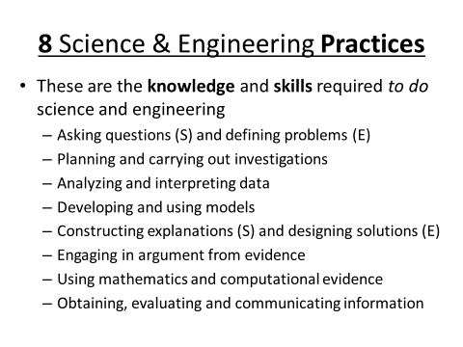To learn more about the Practices, or about NGSS in general:
http://www.crscience.org/educators/practices

